44.9: 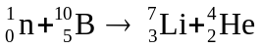
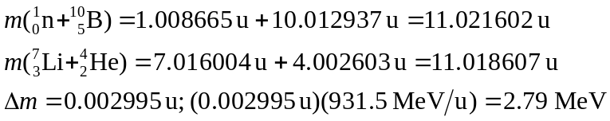
The mass decreases so energy is released and the reaction is exoergic.

